## Taskbar

### General

To open the NavVision ® taskbar menu, select “Tools > Taskbar”.

The taskbar menu is used to configure the taskbar.

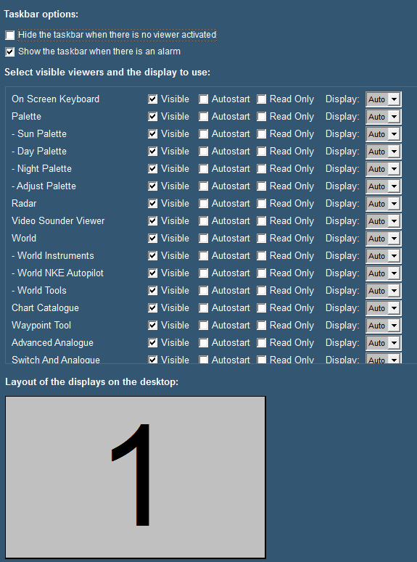

Figure 2‑12: Taskbar menu

The following taskbar settings are available:

|  |  |
| --- | --- |
| **Setting** | **Description** |
| Hide the taskbar when there is no viewer activated | This option allows you to hide the taskbar, in case all viewers are inactive. This function can be disabled, by moving the mouse cursor to the top of the screen. |
| Show the taskbar when there is an alarm | This option allows the taskbar to appear whenever an alarm occurs. This overrides the previous setting of the hidden taskbar. |
| Visible | This option allows you to select the availability of viewers. You can select the viewer that must be displayed and be accessible through the taskbar or not. |
| Autostart | The second option enables you to determine the viewers that automatically open at startup of the software. |
| Read Only | This option prevents people to alter settings in the viewer or mimic |
| Display | The display box defines the screen used for each viewer. The number shown symbolizes the displays as shown at the bottom of the screen. “Auto” means that it will appear at the first free screen. If there is a number, the viewer will appear on that screen. Only available if you have more screens attached. |
| Layout of the displays on the desktop | This setting allows you to show the placement of the different screens connected to your system. The display order, size and the number available for display of viewers are shown. |

*: As of release 3522 it is possible to hide the “close” button to make sure people do not shutdown the program accidently. Just uncheck the checkmark box for the close button*